Project - High Level Design
on ProjectTitle
  - Course Name: DevOps

Institution Name: Medicaps University – Datagami Skill Based Course

Sr no | Student Name | Enrolment Number
1 | SUHANI MOGRA | EN22CS301989
2 | VAIBHAV SHRIVASTAVA | EN22CS3011051
3 | TAMANNA KATARIYA | EN22CS3011013
4 | NAMAN PATIDAR | EN22ME303013
5 | SNEHA ARAS | EN22CS301964

Group Name : 05D9
Project Number : 05
Industry Mentor Name: Mr. VAIBHAV
University Mentor Name:Dr. Ritesh Joshis
Academic Year : 2025-26

Table of Contents
1. Introduction
1.1. Scope of the document
1.2. Intended Audience
1.3. System overview
2. System Design
2.1. Application Design
2.2. Process Flow.
2.3. Information Flow
2.4. Components Design
2.5. Key Design Considerations
2.6. API Catalogue
3. Data Access Mechanism
4. Interfaces
5. State and Session Management
6. Non-Functional Requirements
6.1. Security Aspects
6.2. Performance Aspects
7. References

- Introduction
1.1 Scope of the document
This document describes the high-level architecture of a Spring Boot Logistics application
integrated with GitHub CI/CD, Docker, and deployed on AWS EC2 using Tomcat.

1.2 Intended Audience
  - Faculty / Evaluators
  - Project Team Members
  - DevOps Learners
1.3 System overview
The system automates the complete software lifecycle:
- Code written in VS Code
- Stored in GitHub
- Automatically built & tested using GitHub Actions
- Docker image created and pushed to Docker Hub
- Pulled on AWS EC2
- Deployed inside Tomcat container
Users access the application using EC2 Public IP.
- System Design

  - Application Design
- Java Spring Boot REST application
- WAR deployed on Apache Tomcat
- Docker used for containerization
Architectural Design
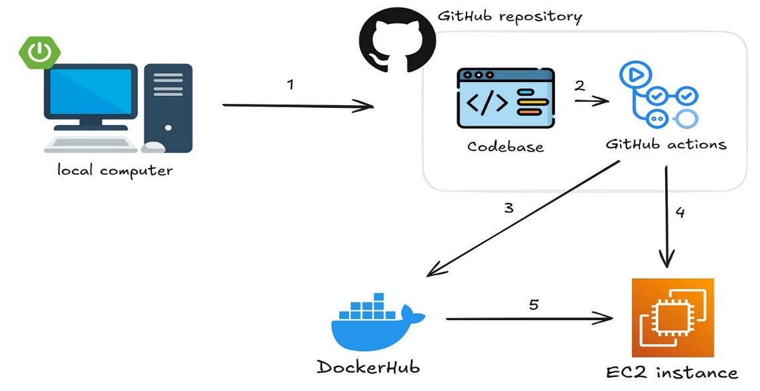

2.2 Process Flow
- Developer pushes code to GitHub
- GitHub Actions runs Maven build + tests
- WAR file generated
- Docker image built
- Image pushed to Docker Hub
- AWS EC2 pulls image
- Container runs Tomcat + application

  - Information Flow
User → EC2 Public IP → Docker Container → Tomcat → Spring Controller → Response
2.4 Components Design
- VS Code – Development
- GitHub – Source control
- GitHub Actions – CI/CD
- Docker Hub – Image storage
- Docker – Container runtime
- Tomcat – Web server
- AWS EC2 – Cloud host
2.5 Key Design Considerations
- Automated deployment
- Portable containers
- Cloud hosting
- Secure credentials (GitHub Secrets)
- Stateless application
2.6 API Catalogue
Endpoint | Method | Purpose
/ | GET | App status
/ health | GET | Health check

3. Data Access
REST APIs : REST APIs expose backend functionality to clients using HTTP methods. They follow REST principles such as statelessness, resource-based URLs, and standard HTTP verbs.

4. Interfaces
- Browser
- REST APIs
- Docker CLI
- GitHub UI
- AWS Console

5. State & Session Management
State and Session Management define how user data and application context are maintained across multiple requests.
In this Logistics Application, the system is designed as a stateless application, meaning:
- The server does not store client session data
- Each request contains all necessary authentication and context information
- No in-memory session tracking is maintained on the server
This design improves scalability, fault tolerance, and cloud compatibility.

6 Non-Functional Requirements
6.1 Security
- EC2 Security Group (22, 8080)
- GitHub Secrets
- Docker isolation

6.2 Performance
- Fast startup (~3 sec)
- Lightweight containers
- Automated builds

7. References
Spring Boot, Docker, GitHub Actions, AWS EC2, Tomcat Docs

